CSA1737 – ARTIFICIAL INTELLIGENCE
LIST OF EXPERIMENTS

- Write a python program to implement Simple Calculator program?
AIM:
To write a Python program to perform basic arithmetic operations such as addition, subtraction, multiplication, and division.
ALGORITHM:
- Start the program.
- Get two numbers from the user.
- Display the arithmetic operation choices.
- Get the user's choice.
- Perform the selected operation using if-elif-else.
- Display the result.
- Stop the program.
CODE:
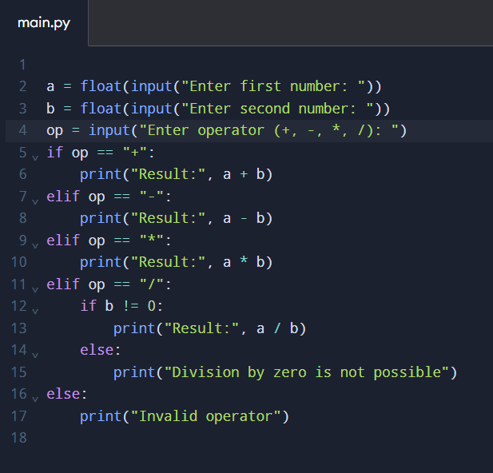
OUTPUT:
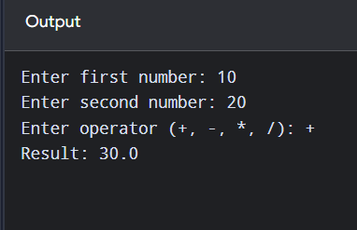

- Write a python program to Add Two Matrices.

AIM:
To write a Python program to add two matrices.
ALGORITHM:
- Start the program.
- Initialize two matrices, A and B.
- Create an empty matrix C to store the result.
- Add the corresponding elements of A and B using nested loops.
- Store the sum in matrix C.
- Display the resultant matrix.
- Stop the program.
CODE :
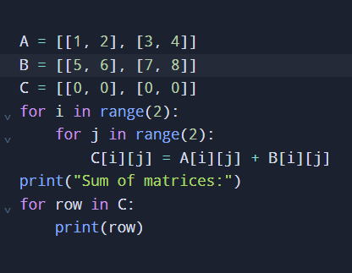

OUTPUT:
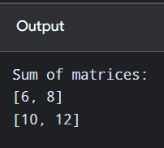

- Write a python program to Transpose a Matrix.
AIM:
To write a Python program to find the transpose of a matrix.
ALGORITHM:

- Start the program.

- Initialize a matrix A.

- Create an empty matrix to store the transpose.

- Use nested loops to interchange the rows and columns.

- Store the elements in the transposed matrix.

- Display the transposed matrix.

- Stop the program.

CODE :
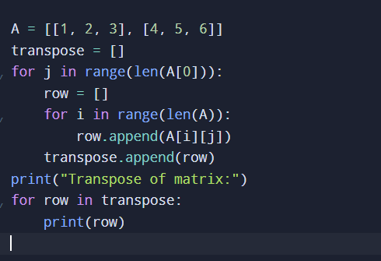
OUTPUT:
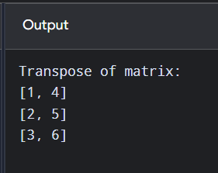

- Write a python program to sort the sentence in alphabetical order?

AIM:
To write a Python program to arrange the words of a sentence in alphabetical order.
ALGORITHM:
- Start the program.
- Get a sentence from the user.
- Split the sentence into individual words.
- Sort the words in alphabetical order.
- Join the sorted words into a sentence.
- Display the sorted sentence.
- Stop the program.
CODE:
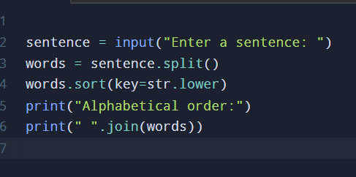

OUTPUT:
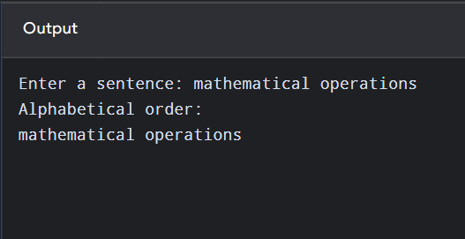

5. Write a python program to implement List operations (Nested List, Length, Concatenation, Membership, Iteration, Indexing and Slicing)?
AIM:
To write a Python program to perform list operations such as nested list, length, concatenation, membership, iteration, indexing, and slicing.
ALGORITHM:
- Start the program.
- Create a nested list.
- Find the length of the list using len().
- Concatenate two lists using the + operator.
- Check membership using the in operator.
- Iterate through the list using a for loop.
- Access an element using indexing.
- Extract elements using slicing.
- Display the results of all operations.
- Stop the program.

CODE:
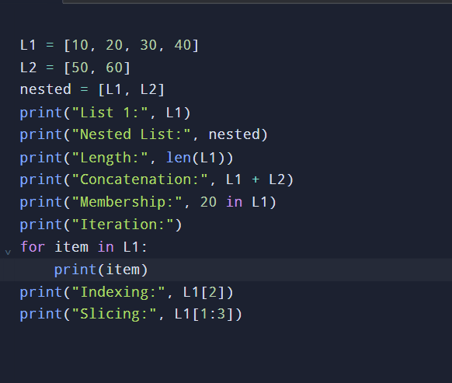
OUTPUT:
